**Explore Hawaii**

**Portfolio Project**

**1. Introduction**

I plan to create a Hawaii travel website. The main navbar will include home, things to do, cuisine, accommodation. I might add other things later on. The navbar will be sticky to top.

**2. User Interface Design and Prototype**

It will have a background picture for the main page, with the project title “Explore Hawaii” in the middle.

After that, I would like to use 4 main islands map outlines to be the layout for users to select for things-to-do section. When user click on one island, the map outline will become bigger. Since I have started to build this website, I screenshot the design interface when selecting Maui island:

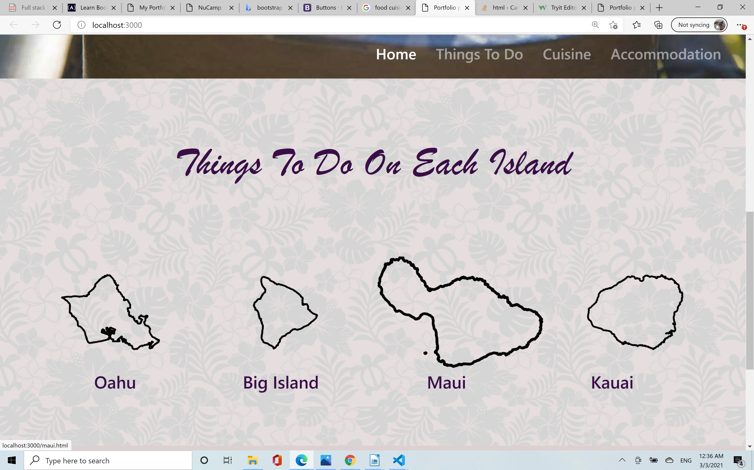

**3. Navigation Structure**

For the flow of user experience, when user select things-to-do navbar, it will take them to the above 4 island select section, then take them to the things-to-do page for each island based on their selection. Inside each things-to-do page, I will create carousel slides for the activities. For the cuisine section, since they are pretty similar across all the islands, I plan to just have them all in at one place. It will be after the island select section, and I will create maybe 6 cards with images and words for this sections. For the accommodation section, it will be a search form with options for dates, locations, price range, etc. It can be after the cuisine section.

**4. References**

https://www.hawaii.com/

https://www.gohawaii.com/

https://www.hawaii-aloha.com/

https://www.hawaiitourismauthority.org/

https://www.hawaii-guide.com/

https://www.visitseattle.org